1.) Create a class named 'Rectangle' with two data members- length and breadth and a function to calculate the area which is 'length\*breadth'. The class has three constructors which are :

1 - Having no parameter - values of both length and breadth are assigned zero.

2 - Having two numbers as parameters - the two numbers are assigned as length and breadthrespectively.

3 - Having one number as parameter - both length and breadth are assigned that number.

Now, create objects of the 'Rectangle' class having none, one and two parameters and print their areas.

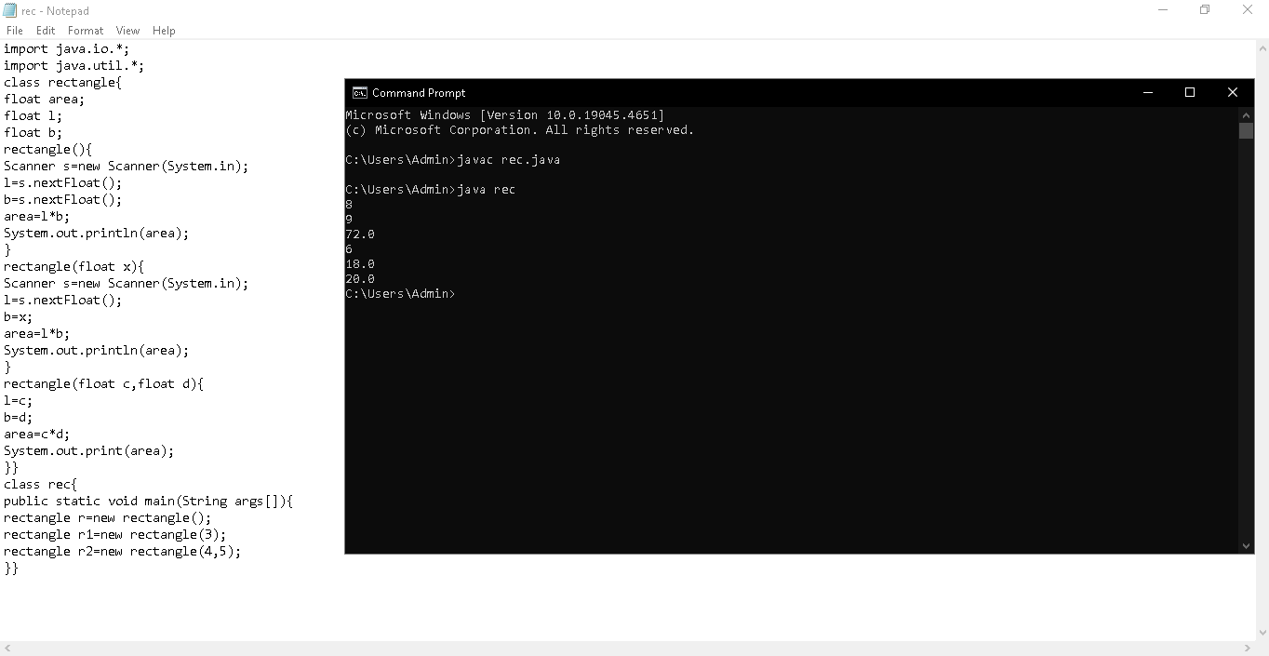

2.) Suppose you have a Piggie Bank with an initial amount of $50 and you have to add some more amounts to it. Create a class 'AddAmount' with a data member named 'amount' with an initial value of $50. Now make two constructors of this class as follows:

1 - without any parameter - no amount will be added to the Piggie Bank

2 - having a parameter which is the amount that will be added to the Piggie Bank

Create an object of the 'AddAmount' class and display the final amount in the Piggie Bank.

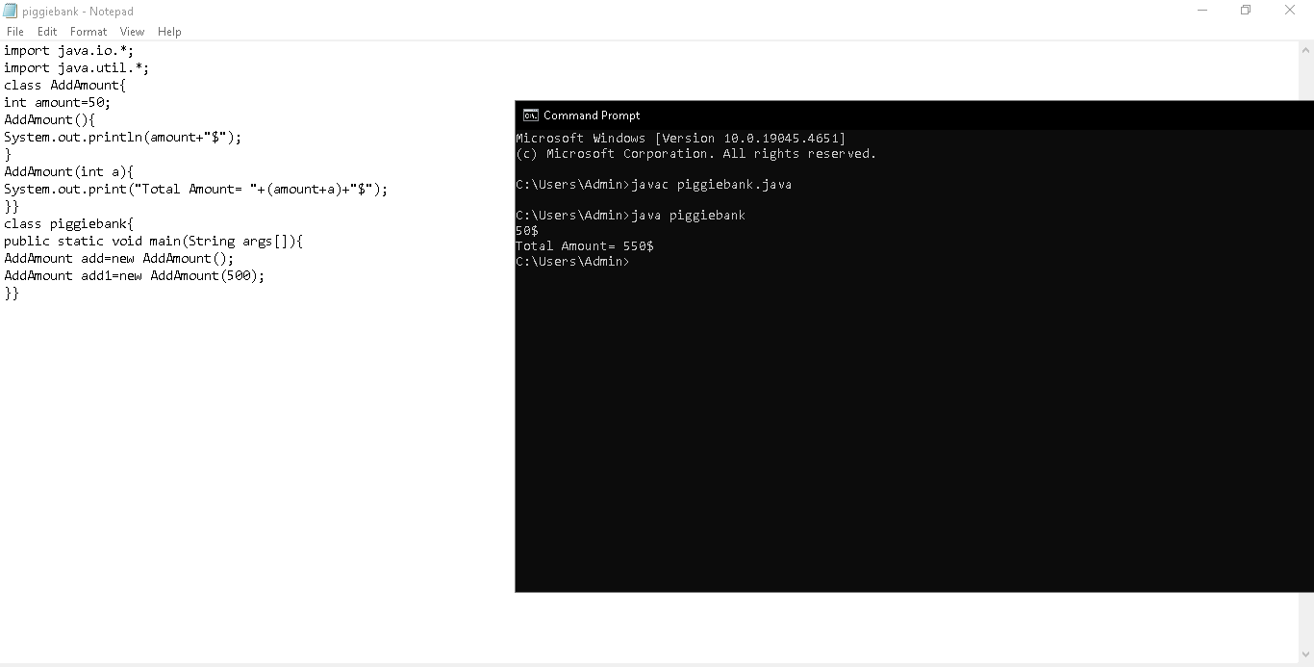

3.) Create a class to print the area of a square and a rectangle. The class has two functions with the same name but different number of parameters. The function for printing the area of rectangle has two parameters which are its length and breadth respectively while the other function for printing the area of square has one parameter which is the side of the square.

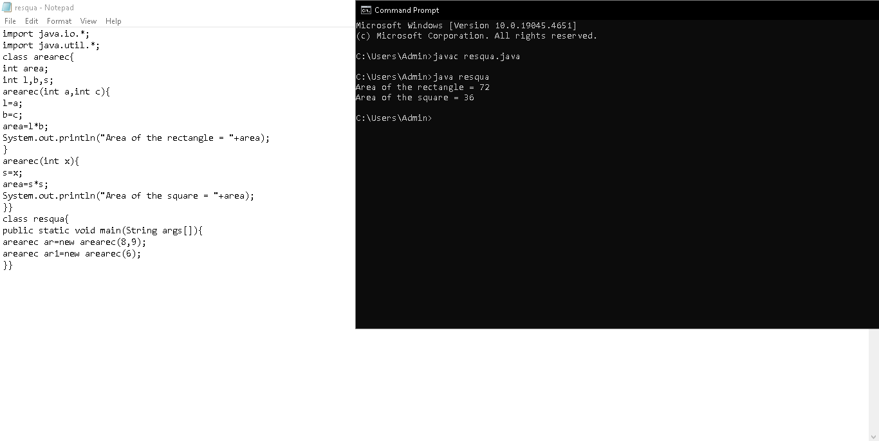

4.) Write a program to print the names of students by creating a Student class. If no name is passed while creating an object of the Student class, then the name should be "Unknown", otherwise the name should be equal to the String value passed while creating the object of the Student class.

